DATABASE

SPECIFICATIONS

Myki Card Transportation System Database
Jordan Chiou,
jungdechiou@gmail.com

School of Computing Technologies, RMIT University

March, 2025

Revision Sheet

Release No. | Date | Revision Description
Rev. 0 | 26/03 | Complete Chapter 1 – General Information
Rev. 1 | 13/04 | Refine Chapter 1 and Building chapter 2

DATABASE SPECIFICATIONS

TABLE OF CONTENTS

Page #

1.0 GENERAL INFORMATION
1.1 Purpose
1.2 Scope
1.3 System Overview
1.4 Project References
1.5 Acronyms and Abbreviations
1.6 Points of Contact
1.6.1 Information
1.6.2 Coordination
1.6.3 Additional Points of Contact
1.6.4 Data Owners
2.0 DATABASE IDENTIFICATION AND DESCRIPTION
2.1 Naming Conventions
2.2 Database Identification
2.3 Systems Using the Database
2.4 Relationship to Other Databases
2.5 Schema Information
2.5.1 Description
2.5.2 Physical Design
2.5.3 Physical Structure
2.6 Data Dictionary
2.7 Special Instructions
3.0 DATABASE ADMINISTRATIVE INFORMATION
3.1 Responsibility
3.2 System Information
3.2.1 Database Management System (DBMS) Configuration
3.2.2 Hardware Configuration
3.2.3 Database Software Utilities
3.2.4 Support Software Available for Maintaining Database
3.2.5 Security
3.3 Storage Requirements
3.4 Recovery
3.5 Partition/File Information
3.5.1 Content
3.5.2 Description
3.5.3 Partition/File Interdependencies
3.6 Database Interfaces
3.6.1 Description of Operational Implications
3.6.2 Description of Data Transfer Requirements
3.6.3 Description of Formats of Data
3.7 Error Handling

1.0 GENERAL INFORMATION

GENERAL INFORMATION

1.1 Purpose
This document defines the logical and physical design specifications for the Myki Card Transportation System Database. The primary purpose of this specification is to replicate the core functionality of the existing Myki system while focusing on optimising its backend database performance, including:
- Touch-on / touch-off trip recording
- Fare calculation and capping rules
- Transaction tracking (fare deductions and top-ups)
- Vehicle and station tracking for determining travel locations
- System extensibility for various transport modes (tram, train, bus)
This project aims to address the key database performance bottlenecks identified in the current system by applying advanced database design principles, such as index tuning, partitioning strategies, and effective storage management. Additionally, this specification estimates long-term storage requirements for the next 10 years based on projected usage growth and data accumulation patterns.
The proposed database model is designed for implementation in a Microsoft SQL Server environment and serves as a reference for database administrators, system developers, and other stakeholders involved in its development and maintenance.

1.2 Scope
This database specification defines the design and structure of the backend relational data storage for the Myki Card System, with a primary focus on supporting public transport operations within the metropolitan area for full-fare and concession passengers.
In particular, this specification covers:
- Modelling of Myki cards and customer account information
- Capturing touch-on and touch-off events through scanning devices
- Recording trip histories along with relevant travel metadata
- Storing transaction records for fare deductions, top-ups, and refund.
- Integrating vehicles, routes, and stop stations to determine precise device location data
- Deriving boarding and alighting stations based on vehicle movement logs and GPS tracking data
The scope of this specification explicitly excludes regional transport logic and any integration with external fare enforcement or financial settlement systems. These components may be considered for future system enhancements.
This defined scope provides a robust foundation for capturing and processing core Myki usage scenarios while ensuring the database design is extensible for future operational requirements.

1.3 System Overview
This system represents a simplified smartcard fare collection platform similar to the Myki card system used in Victoria's metropolitan public transport network. Its objective is to serve as a proof-of-concept for implementing advanced relational database design and optimisation techniques in a public transport setting.
The database design emphasises key operations such as touch-on/touch-off event processing, trip logging, fare calculation, transaction recording, and vehicle location data integration. This system creates a structured environment for demonstrating database modelling principles, performance tuning methods, and storage optimisation techniques.
- Responsible organisation:
Not Applicable—This system was developed as part of an academic coursework project within RMIT University for educational purposes. No formal organisation is responsible for production operations.
- System name or title:
Myki Card Transportation System Database
- System code:
Not Applicable
- System category:
Major application — The system performs defined functions (touch-on, trip tracking, fare deduction) with identifiable logical components and business rules. This system is not a general-purpose support system.
- Operational status:
Under Development — This system is in the design and prototyping phase for academic demonstration and is not intended for production deployment.
- System environment and special conditions:
This database system is developed within a controlled educational environment. Key assumptions and design conditions include:
- Target Relational Database Management System (RDBMS): Microsoft SQL Server
- Assumes integration with simulated GPS and log-based inputs for vehicle movement tracking
- Focus is limited to backend database design; no front-end interface, API integration, or external payment processing components are within the scope of this system.

1.4 Project References
The following external resources were used to inform and support the design of this database specification:
- Public Transport Victoria (PTV) GTFS Feed – Vehicle Types
URL: https://data.ptv.vic.gov.au/downloads/GTFSReleaseNotes.pdf
- Train Service Passenger Counts – Data Structure Reference
URL: https://discover.data.vic.gov.au/dataset/train-service-passenger-counts/resource/162887ef-1dba-4d9b-83bd-baee229229c6
- TramTracks Real-Time Tram Location Feed
URL: https://discover.data.vic.gov.au/dataset/tram-tracks/resource/60dc379e-1ac9-4e3c-9dca-c428f5c014f0
- Myki Fare Structure – Metropolitan Zones and Default Fares
URL: https://www.ptv.vic.gov.au/tickets/fares/metropolitan-fares/#defaultfares
- Victoria Population projection:
URL: https://www.planning.vic.gov.au/__data/assets/pdf_file/0022/703453/DTP0552-Victori-in-Future-2023-report.PDF
- Method of travel to work:
https://www.abs.gov.au/census/guide-census-data/census-dictionary/2021/variables-topic/transport/method-travel-work-mtwp
- PTV Annual report:
https://www.vic.gov.au/dtp-annual-report

1.5 Acronyms and Abbreviations
Acronyms or Abbreviations | Description
DB | Database
DBMS | Database Management System
RDBMS | Relational Database Management System
PTV | Public Transport Victoria
GPS | Global Positioning System
SQL | Structured Query Language
T-SQL | Transact-SQL (Microsoft SQL Server extension to SQL)
ERD | Entity-Relationship Diagram
RMIT | Royal Melbourne Institute of Technology
udf | User Defined Function
usp | User Stored Procedure

1.6 Points of Contact

1.6.1 Information
Name: Jordan Chiou
Role in this project: Database Designer
Contact: jungdechiou@gmail.com / s4068959@student.rmit.edu.au

1.6.2 Coordination
Not Applicable — No additional coordination roles are defined for this project.

1.6.3 Additional Points of Contact
Not Applicable — No other contributors or stakeholders are involved in this project.e

1.6.4 Data Owners
Data Owner | Responsibility
Jordan Chiou | Responsible for database design, data modelling, and overall data ownership for the project.

2.0 DATABASE IDENTIFICATION AND DESCRIPTION

DATABASE IDENTIFICATION AND DESCRIPTION

2.1 Naming Conventions
- Logical Naming Conventions:
Logical names are used in entity-relationship (ER) diagrams and conceptual discussions.
- Entities (tables) use PascalCase, singular form.
  - Example: MykiCard, Trip, VehicleRun, StopStation
- Attributes (columns) use snake_case, descriptive and self-explanatory.
  - Example: card_id, touch_on_time, vehicle_type
- Primary keys are named as entity_name_id or abbreviated as xxx_id followed with {PK} symbol.
  - Example: trip_id {PK}, route_id{PK}
- Foreign keys are not explicitly marked in this ER diagram but are named identically to the referenced primary key.
  - Example: card_id in Trip references MykiCard.card_id
- Enumerated values (e.g. CardType, VehicleType) are shown as fixed values or look-up tables.
- Physical Naming Conventions (SQL Server)
These conventions apply to the actual implementation of the schema in SQL Server.
- Schema prefix: All tables are implemented under the default dbo schema, and the “dbo.” prefix is used in all fully-qualified object references.
  - Example: dbo.VehicleRun, dbo.Trip
- Table names: Use PascalCase without pluralisation, consistent with the logical model.
- Column names use lowercase with underscores (snake_case), consistent with the logical model.
- Constraint names: Follow a descriptive format with standard prefixes. These reflect the associated table and attribute(s).
  - Example: CK_CardTransaction_Amount, FK_Trip_CardID
- Index names: Use the prefix IX_ followed by the table name, columns, or index purpose.
  - Example:
  - IX_Trip_Card_TouchOn – for fast lookups by card and time
  - IX_Trip_UnfinishedTripCheck – for checking active trips during touch-on
- Data types: Chosen based on the attribute’s nature and expected range of values.
  - Example: DECIMAL(10,2) for monetary values, DATETIME2(0) for timestamps, and VARCHAR(100) for textual fields

2.2 Database Identification
The database defined in this specification is logically referred to as:
| MykiTransportDB
This logical name denotes the intended schema design for simulating the Myki card fare collection system in a metropolitan public transport network. However, the actual database name on the instructional Microsoft SQL Server is limited to the student ID s4068959, representing the real Database Name on this database design's SQL server. The schema is set to dbo, and all table-level design and naming conventions follow the logical data model outlined in this document.The schema is implemented using a single consistent structure, with each table name serving as a unique, descriptive identifier. Prefixes or abbreviations are avoided to maximise readability and traceability.
Database Code Name
- Logical Database Name: MykiTransportDB
- Actual Database Name(SQL Server): s4068959
Table Identifier:
Table Name | Description
CustomerAccount | Stores user information for registered customers
MykiCard | Represents each issued card, balance, and type
CardType | Enumerated card fare types (full-fare, concession, etc.)
MykiPass | Record of Myki pass purchased by users with start date and expiry date
FareType | Lookup table for types of fare (default_fare, free_2hours, etc.)
Trip | Captures travel journeys initiated by card taps
CardTransaction | Logs monetary operations such as fare deductions or top-ups
Scanner | Represents touch-on/off scanning devices
DeviceLocation | Abstract link between scanner and physical location
StopStations | Fixed locations where passengers board or alight
Route | Defines public transport routes
RouteStop | Mapping of ordered stop points for each route
Vehicle | Transport units (tram, bus, train)
VehicleType | Lookup for types of vehicles
VehicleRun | A scheduled or real-time instance of a vehicle operating a route
VehicleStopLog | System-generated record of vehicle arrival/departure at stations
VehicleRealTimeLog | Raw GPS location log for tracking vehicle movement
Calendar | Aligned with the national calendar to decide which day is a weekend and a holiday for the pricing system

Within the scope of the Mykitransportdb schema, all table names are unique and self-descriptive. The naming conventions are applied to ensure consistency, clarity, and ease of maintenance across database development and operation activities.

2.3 Systems Using the Database
Not Applicable—This database is designed for academic demonstration purposes only. No external systems or applications are connected to it. During development and testing, all operations and data access are performed directly within the Microsoft SQL Server environment.

2.4 Relationship to Other Databases
Not Applicable — This database operates as a standalone system for academic demonstration purposes. There is no integration with external databases or data exchange with other systems. All data required for the Myki Card Transportation System is self-contained within the MykiTransportDB schema.
Design Note:
If the system were to be extended for real-world deployment, it is recommended to separate database systems based on business domains to improve scalability, maintainability, and system performance. For example:
- A dedicated Myki Payment Database to handle card management, fare calculation, and transaction processing (Blue components in the ERD).
- A separate Vehicle Operation Database to manage real-time vehicle location tracking and operational logs (Green components in the ERD).

2.5 Schema Information

2.5.1 Description
The database is structured as a single schema logically named myki, representing a modular and normalised relational structure. This schema includes all entity, reference, and operational tables to simulate a Myki card-based fare management system in a metropolitan transport context.
In the instructional Microsoft SQL Server environment, the implementation uses the default schema name dbo. To maintain conceptual clarity, all the logical design adheres to the MykiTransportDB naming convention throughout this document.
2.5.1.1 Schema Name
- Logical schema name: myki
- Actual schema name (SQL Server): dbo
- Target RDBMS: Microsoft SQL Server
2.5.1.2 Sub-schemas
- Not Applicable — the system is implemented as a single schema without physical sub-schemas.
2.5.1.3 File Type / Data Model
- The database follows a relational data model and generally adheres to Third Normal Form (3NF) principles to minimise redundancy and ensure data integrity.
- However, selected controlled denormalisation is intentionally applied in specific tables to improve performance, like the DeviceLocation table includes a redundant field current_stop_station_id to enable faster real-time access.
- All tables are defined using SQL Data Definition Language (DDL) statements compatible with Microsoft SQL Server.
- Constraints are applied at both table and column levels to enforce data integrity, including primary keys, foreign keys, and check constraints (e.g., enforcing non-negative transaction amounts and logical date relationships).
- Additional T-SQL stored procedures or functions are implemented for specific business logic (e.g., touch-on, touch-off, checkFareType operations, etc.)
2.5.1.4 Access Control Keys
- Not Applicable — User-level access control is not implemented in this academic prototype. All database operations are executed within a trusted environment, and no role-based access management is required at this stage.
2.5.1.5 Concurrency and Locking
- The default concurrency control mechanisms provided by Microsoft SQL Server are used. No custom locking logic or isolation level overrides have been implemented.
- The system relies on SQL Server's default Read Committed isolation level, which is sufficient for this version's operational requirements. Alternative strategies (e.g., snapshot isolation, row-level locking hints) may be evaluated if future versions require higher transaction throughput or consistency guarantees.
2.5.1.6 Data Name Mapping
- All table and column names follow the naming conventions defined in Section 2.1. Table names use PascalCase and column names use snake_case to maintain clarity, readability, and consistency across the schema.
- In Microsoft SQL Server, all objects are defined under the default schema dbo. As such, fully qualified table references follow the dbo.TableName format (e.g., dbo.Trip, dbo.MykiCard).
- User-defined functions follow the prefix convention udf_FunctionName (e.g., udf_IsHoliday) to clearly distinguish them from built-in functions.
- Stored procedures follow the prefix usp_ProcedureName (e.g., usp_TouchOn) to reflect their procedural nature and usage context.
- This version does not introduce aliases, synonyms, or abstraction layers in order to maintain schema simplicity and minimise interpretative overhead during development and testing.
2.5.1.7 Partition and File Limitations
- No table or index is horizontally sharded across multiple filegroups.
- The entire schema is hosted within a single logical database instance, under the default SQL Server configuration provided in the teaching environment.
- Due to platform restrictions, all objects are stored within the default PRIMARY filegroup, and custom filegroup allocation is not supported in this deployment.
- While selected high-volume tables are logically partitioned to improve query performance and support scalability, physical-level filegroup optimisation (e.g., I/O balancing, storage tiering, or multi-disk parallel access) is considered out of scope for this academic implementation.
2.5.1.8 Access Path Restrictions
- No materialised views, full-text indexes, or computed columns are defined in this version.
- A logical view (vwCustomerAccount) is implemented to support unified access to vertically partitioned data from CustomerAuth and CustomerProfile. This view is not indexed and is intended for convenience during data retrieval only.
- All other data access is performed through direct queries on base tables, using defined primary and foreign key constraints, along with manually created indexes optimised for touch-on/off and trip-tracking operations.

2.5.2 Physical Design
The physical design of the database represents the conceptual structure of the system as implemented through entity relationships.
Figure 2.1 below illustrates the complete Entity-Relationship Diagram (ERD) that defines the entities, relationships, and key constraints within the MykiTransportDB schema.
The ERD is logically divided into two thematic segments:
- Blue section: Represents the Myki Card management logic, including cards, accounts, transactions, trips, scanners, and passes. This is the primary focus of the database design.
- Green section: Represents vehicle and route-related data, which is included to support trip recording and fare calculation based on movement. This section is intentionally simplified, as it plays a supporting role to the card interaction logic.
In addition, several design assumptions and notes are outlined below to support the simplification or interpretation of certain data elements where explicit documentation from the real-world Myki system is unavailable.
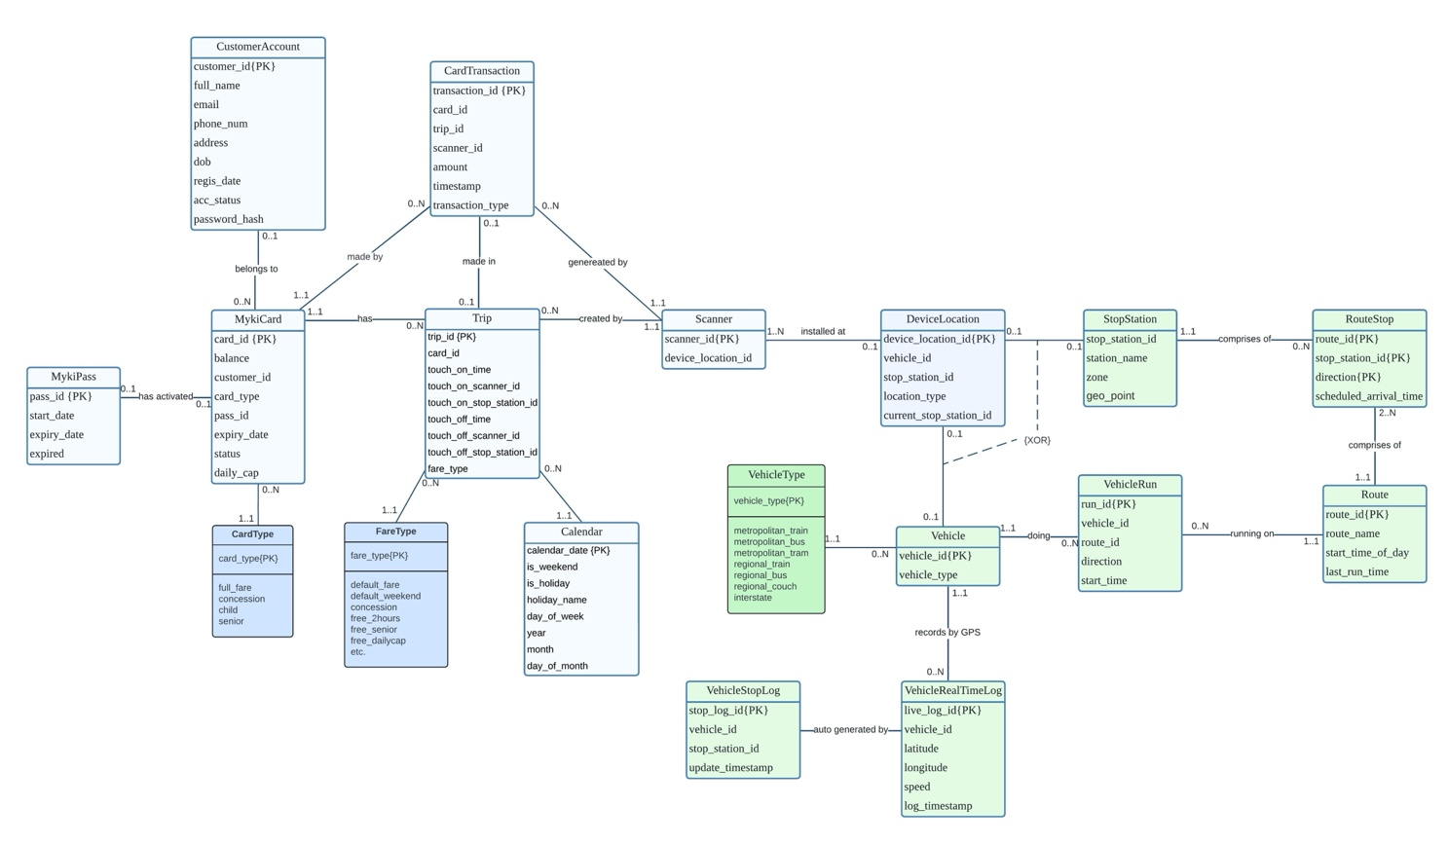
Figure 2.1
2.5.2.1 Notes:
  - MykiCard Table:
    - MykiCard records may exist without an associated customer account. These represent anonymous cards.
    - Card balances can go down to a maximum overdraft of –10 AUD.
    - The status field and expiry_date should remain consistent — cards with status = 0 (expired) should have an expiry date earlier than the current date.
  - Calendar Table:
    - This table is used by the CardTransaction logic to differentiate between weekday and weekend fare policies.
    - This table is manually constructed for testing purposes and does not pull data from an external or government calendar API.
  - Scanner Table:
    - Each Scanner is assigned to one DeviceLocation, while a single DeviceLocation (e.g., a tram or a station) may host multiple scanners.
    - Top-up machines are treated as scanners for simplicity. However, the specific logic of the top-up process is outside the scope of this project.
  - DeviceLocation Table:
    - In the DeviceLocation table, the attributes vehicle_id and stop_station_id are mutually exclusive — a scanner cannot be located in both a vehicle and a fixed stop.
    - For online transactions, the location_type is set to "online"; for physical interactions, it is set to "physical".
  - This design does not explicitly differentiate between transport modes (e.g., tram vs. train) in terms of stop or route logic. The stop and route structure is simplified to test zone-based fare calculations rather than implement a full transport network simulation.

2.5.2.2 Assumptions & Justifications
- All Vehicles Require Touch-On and Touch-Off
Assumption: All public transport vehicles in the system, including trams, require both touch-on and touch-off actions.
Changes:
- This deviates from the current real-world tram system, which does not enforce touch-off.
- Under this assumption, fare deductions only occur upon touch-off.
- The system maintains the current forgot-to-touch-off policy, where a full “Zone 1+2 2-hour” fare is charged when passengers forget to touch off.
Benefits:
- Establishes a uniform usage pattern for all Myki cards, improving user understanding and system predictability.
- Enables PTV to collect more granular trip data for future analysis, especially regarding tram usage.
- Lays the groundwork for future transitions from zone-based pricing to distance-based dynamic fare models.
- Real-Time GPS Logging Every 30 Seconds
Assumption: Each vehicle has a GPS device that sends location updates every 30 seconds. These logs are directly stored in the VehicleRealTimeLog table.
Justification: This simulates a common real-time vehicle tracking system used in intelligent transport infrastructure and provides accurate location snapshots for determining stop arrival patterns and trip routes.
- Stop Log Generation Based on Real-Time Location
Assumption: The VehicleStopLog table is derived from real-time location data (VehicleRealTimeLog).
While not implemented in this version, the design assumes the system would:
- Compare GPS coordinates with known StopStation locations
- Use vehicle_id and vehicle_type to avoid misclassifying stop points (e.g., assigning a tram stop to a bus)
- Determine the nearest matching stop and route for each entry to decide which stop_station_id the vehicle belongs to.
Justification: This process mirrors real-world transit systems that geofence or match GPS coordinates to scheduled stop points for accurate trip recording.
- Dynamic Update of DeviceLocation Based on Vehicle Stop
Assumption: The current_stop_station_id in the DeviceLocation table is dynamically updated based on the most recent VehicleStopLog entry for the associated vehicle if the stop_station_id has changed.
Justification:
- Improves real-time accuracy of location data during touch-on/off operations.
- Avoids expensive multi-table joins by allowing the scanner to reference the current location directly from DeviceLocation.
- Pass Expiry and Card-Pass Association Management
Assumption: A MykiCard is associated with a MykiPass via the pass_id field in the MykiCard table.
The design assumes a background process (not implemented) that:
- Periodically checks for expired passes
- Sets expired = 1 in the MykiPass table when expiry is detected
- Sets the corresponding MykiCard.pass_id = NULL to indicate disassociation from an invalid pass
Justification:
- Provides a simple yet effective way to detect active pass usage on a card
- Keeps card and pass relationships clean without requiring complex joins or subqueries during fare evaluation

2.5.3 Physical Structure
This section of the MykiTransportDB database captures the actual implementation within Microsoft SQL Server. The deployed schema’s concrete components, including partitioned tables, indexing strategy, and runtime data structure, are documented here. Figure 2.2 below shows a graphical overview of the physical structure as implemented.
While the ERD in Figure 2.1 illustrates the logical relationships among entities, the actual implementation may diverge due to database-level constraints such as partitioning, foreign key enforcement, and practical performance considerations.
For instance, the Trip table is partitioned by touch_off_time, as only completed trips (i.e., those with a non-placeholder touch_off_time) are eligible for fare calculation and archiving. As a result, touch_off_time must be included in the primary key. This, in turn, affects related tables such as CardTransaction, which must also include touch_off_time in their foreign key reference to maintain referential integrity under SQL Server's partitioning constraints.
Another example is the relationship between Trip and Calendar, which is modelled logically in the ERD but implemented as a function-based lookup. Instead of using an enforced foreign key, fare calculation queries retrieve the relevant calendar attributes dynamically based on the current date. This design provides greater flexibility and reduces join complexity in the touch-on/touch-off process.
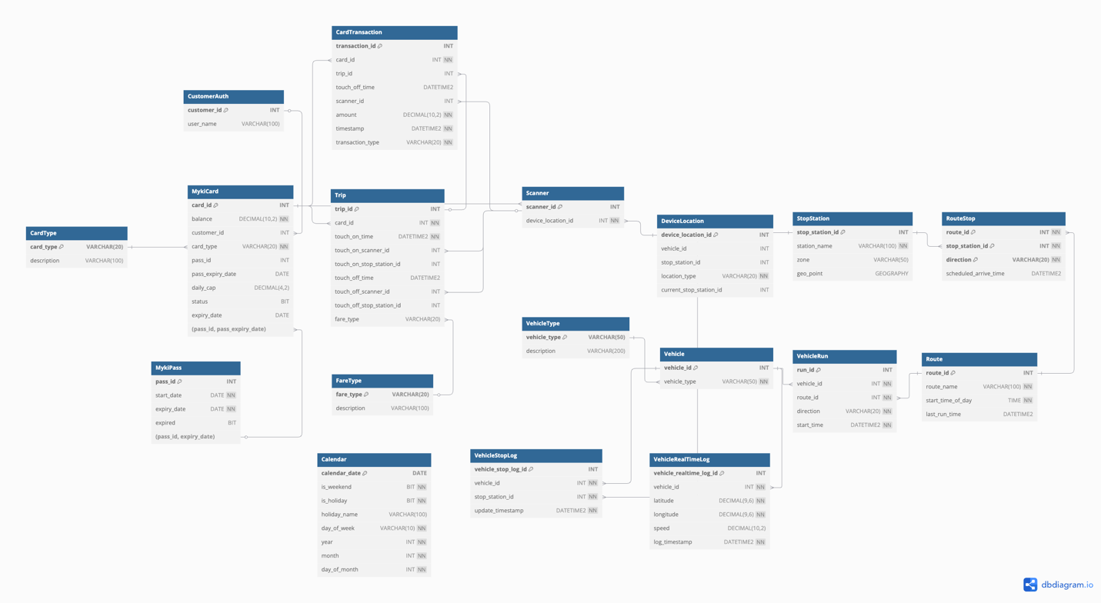
Figure 2.2
2.5.3.1 Partitioning Strategy
Horizontal partitioning has been implemented on selected high-volume tables using DATETIME2 fields to improve scalability and enhance query performance. A monthly range-based partitioning strategy is in place, executed through a partition scheme (ps_Monthly) and a corresponding partition function (pf_Monthly) that defines boundary ranges for each month.
The existing partition function covers 2024-02-01 to 2030-02-01 (exclusive), encapsulating six years of anticipated operational activity. This partitioning is applied to tables such as Trip, CardTransaction, VehicleStopLog, and VehicleRealTimeLog, which all manage rapidly growing time-series data.
Monthly partitioning offers a reasonable balance between query efficiency and the management overhead of partitions. Although daily partitioning might enhance write throughput for significantly large datasets, it has been intentionally dismissed to mitigate the risk of generating too many partitions. The excessive partitioning would substantially increase metadata overhead and complicate storage management in SQL Server.
Additionally, a secondary partition scheme (ps_Yearly) and a function(pf_Yearly) have been established to accommodate potential expansion for archival tables, such as MykiPass, that may benefit from broader yearly-based partitioning dates.

Table | Partition Key | Partition Strategy
Trip | touch_off_time | Monthly range partition
CardTransaction | timestamp | Monthly range partition
VehicleStopLog | update_timestamp | Monthly range partition
VehicleRealTimeLog | log_timestamp | Monthly range partition
MykiPass | expiry_date | Yearly range partition
Vertical partitioning is applied to the CustomerAccount table to optimise query performance and storage efficiency. This partitioning strategy separates frequently accessed authentication-related data from less frequently used customer profile information.
Specifically, the CustomerAccount table is vertically partitioned into the following two logical tables:
- CustomerAuth: Contains attributes required for user authentication and account management, including customer_id, email, password_hash, acc_status, and regis_date. This table is expected to be frequently accessed during login and account validation processes.
- CustomerProfile: Stores customer profile information that is less frequently accessed or updated, such as full_name, phone_num, address, and dob.
Table | Attributes
CustomerAuth | customer_id (PK), email, password_hash, acc_status, regis_date
CustomerProfile | customer_id (PK), full_name, phone_num, address, dob
To maintain logical consistency and support seamless data access, a view named vwCustomerAccount is implemented to provide a unified interface for querying vertically partitioned customer data. This view abstracts the underlying table separation, allowing external queries to interact with the combined customer record as if it were a single entity.
Additionally, a trigger named trg_vwCustomer_IOI is defined on the view to handle insert operations. When a new record is inserted into vwCustomerAccount, the trigger automatically decomposes the input and executes the appropriate insert statements for both CustomerAuth and CustomerProfile. This design maintains data transparency for end-users while preserving the benefits of vertical partitioning.

Indexing Strategy
Indexing is applied strategically to optimise the performance of critical database operations, particularly for the Touch On process. The process involves frequent lookups on card validation, trip history, transaction records, and scanner location data. Composite and Filtered indexes are designed to support common query patterns and improve data retrieval efficiency:

Table | Indexed Columns | Purpose
Trip | (card_id, touch_on_time) INCLUDE (touch_off_time) | Find the newest record in Trip
Trip | (card_id, touch_on_time DESC) WHERE touch_off_time IS NULL | Used to check if this touch action is touch-on or off
Trip | (card_id, touch_on_time DESC) WHERE touch_off_time IS NOT NULL | Used to check if the user touch off within 2 hours
MykiCard | card_id INCLUDE (pass_id, balance, status, daily_cap, card_type) | Check frequently accessed attributes
VehicleStopLog | vehicle_id, stop_station_id, time_stamp DESC | Check if the same vehicle’s stop_station_id is changed
DeviceLocation | vehicle_id | Used to update current_stop_station_id from VehicleStopLog
VehicleRealTimeLog | vehicle_id, timestamp | Find the recent logs of a certain vehicle

2.6 Data Dictionary

Reference the data dictionary and attach it as an appendix to this document.

2.7 Special Instructions

Identify instructions to be followed by personnel who will contribute to the generation of the database and who will use it for testing and operational purposes. Such instructions may include:

- Identify any specialized criteria for entering data into the database.
- Identify source documents for the rules and procedures to be followed when submitting data for entry into the database.
- Identify source documents for the machine run instructions for generating, modifying, updating, or otherwise using the database. In very large systems, in which the details of such instructions are extensive, reference sections of other documents in which this specific information may be found.

- DATABASE ADMINISTRATIVE INFORMATION

DATABASE ADMINISTRATIVE INFORMATION

3.1 Responsibility

Identify the organizations and personnel responsible for the following database administrative functions: database administrator, system administrator, and security administrator. Describe specific administration skill requirements.

3.2 System Information

Document the Database Management System configuration, hardware configuration, database software utilities, and any support software used.

3.2.1 Database Management System (DBMS) Configuration

Identify the vendor, version or release date and targeted hardware for the DBMS. Describe any restrictions on the initialization and use of the DBMS to support any intended distributed processing.

3.2.2 Hardware Configuration

Identify the hardware configurations on which the database will reside.

3.2.3 Database Software Utilities

List and reference the documentation of any DBMS utility software available to support the use or maintenance of the database.

3.2.4 Support Software Available for Maintaining Database

Describe all support software, including the operating system, directly related to the database, including name, version, function, and major operating characteristics. Cite documentation by title, number, and appropriate sections. Examples of such software include database management systems, query language, report writers, storage allocation software, database loading software programs, and file processing programs, and data cleaning software.

3.2.5 Security

Describe the use and management of integrity and access controls that apply to all database components such as schema, sub-schema, partitions or physical files, records or tables, sets or relations, and data elements.

3.3 Storage Requirements

Describe the storage device. Provide sizing formulas for determining the storage required to support the database content and associated software. Estimate the internal and peripheral storage requirements. Identify multiple storage requirements for distributed processing.

3.4 Recovery

Describe the methodology for reestablishment or recreation of the necessary data schema and system support files.

3.5 Partition/File Information

3.5.1 Content

Describe the content of each partition/file, listing the records it contains and explaining the purpose.

3.5.2 Description

Describe the design and format of each partition/file, including name, type, code, mapping, limitations and controls, access procedures, and mechanisms.

3.5.3 Partition/File Interdependencies

Identify the interdependencies of each partition/file in the database.

3.6 Database Interfaces

Provide a description of the interfaces with other application software including these of other operational capabilities and from other organizations. For each interface, specify the following information:

3.6.1 Description of Operational Implications

Describe operational implications of data transfer, including security considerations.

3.6.2 Description of Data Transfer Requirements

Describe data transfer requirements to and from the software, including data content, format, sequence, and any conversion issues.

3.6.3 Description of Formats of Data

Describe formats of data for both the sending and receiving systems, including the data item names, codes, or abbreviations that are to be interchanged, as well as any units of measure/conversion issues.

3.7 Error Handling

Describe those system error handling routines and procedures that are available during execution of database software.

